The use of the best Airsoft pistol
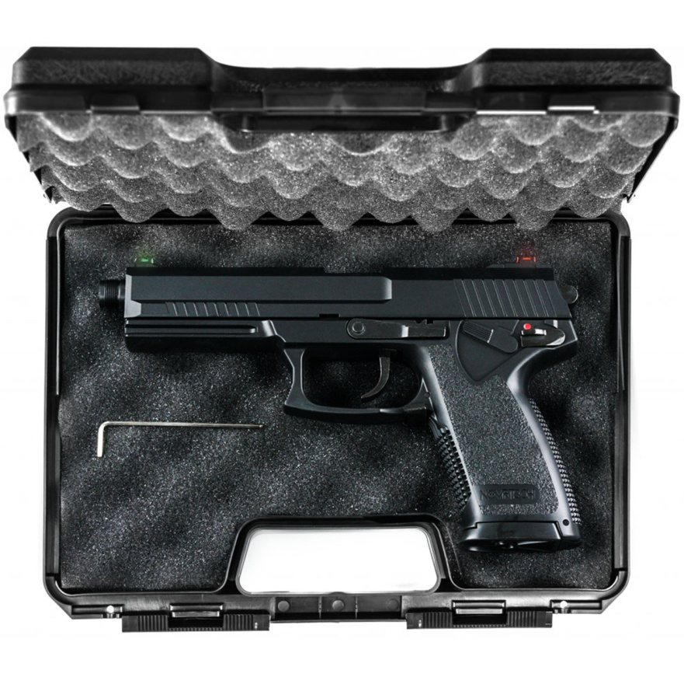
Do you want to know about the best fake toy gun you want to use for any kind of purpose? Here is the perfect solution for you as there is a gun called an Airsoft gun that is the same h a real gun.
You can get to choose different types of Airsoft guns as the details of these kinds of guns are the same as the real gun. On the other hand, it also shoots fake bullets instead of real bullets.
Use of the Airsoft gun
If we talk about the use of these kinds of guns, then there are many purposes like there are many games in which you can get to use this kind of gun. It is also used for training purposes so that you can learn how to use this kind of gun.
There are many things that are responsible for firing fake bullets as there are specialized springs inside the gun that push the bullet with a great force. On the other hand, in some guns, gases are used to fire up the bullets, so there are many techniques used in the gun to make it work.

Please Check provided Link Gearup Airsoft Pistols for Sale
How to select a suitable gun for you?
If you want a gun just for fun, then you should go for the spring guns as they are cheap and used for low-level mechanism. Its life span is so low, and also it is made of low-quality material.
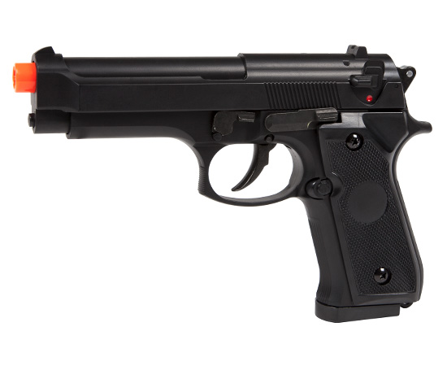
On the other hand, if you want to use the best in the quality gun with high power, then you should use the best in the class gas compressed gun. It uses gas instead of spring, which is high in power, and also, on the other hand, it is expensive as compared to the spring gun.

